Task-1:Flow Diagram Client Browser to Java Backend Servlet

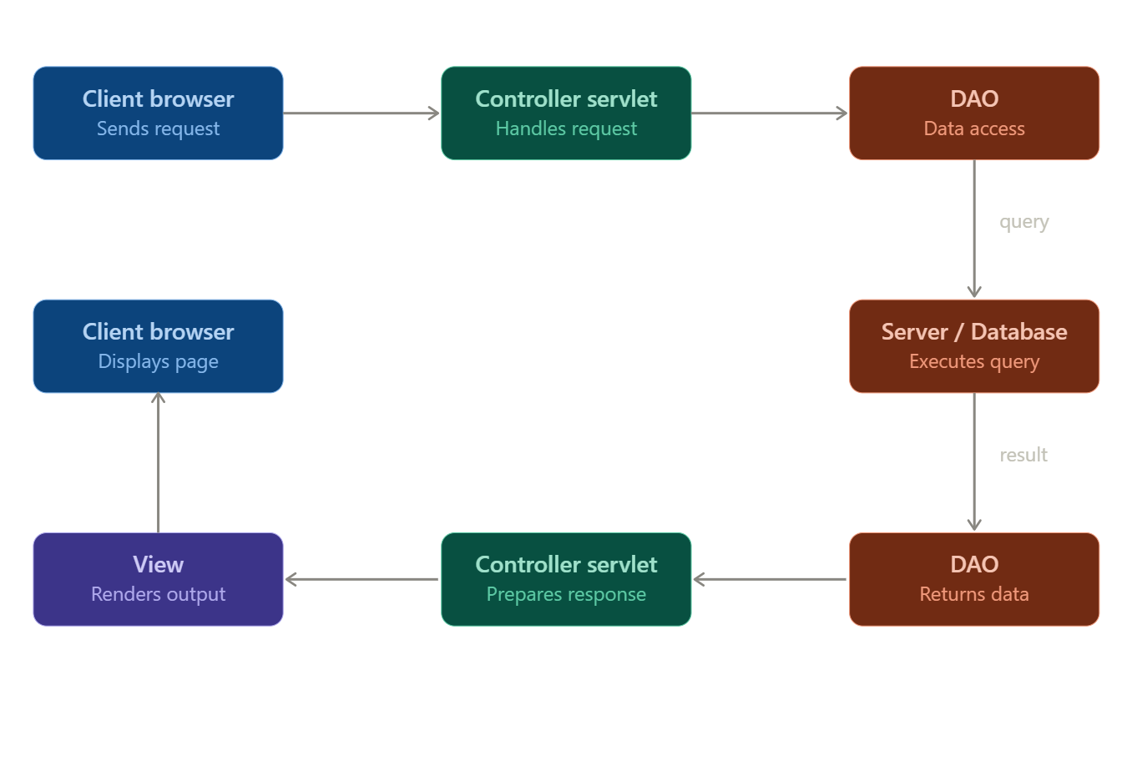

Task-2:Open your browser's DevTools (Network tab) and visit any dynamic page on Zomato or Myntra. Identify and write down one HTTP request URL, its request method (GET/POST), and the response status code you see when searching or filtering items.

Request URL :

https://www.myntra.com/gateway/v4/search/jeans?f=Gender%3Amen%2Cmen%20women&rawQuery=jeans&rows=50&o=0&plaEnabled=true&xdEnabled=false&isFacet=true&p=1&pincode=380001

Request Method :

GET

Status Code :

200 OK

Task-4 Static vs Dynamic Pages

Content Source :

- A Static About Us page has its HTML written once and served as is to everyone who visits - the content lives directly in the file.
- The Instagram feed is generated on the fly by a server pulling from a database, so HTML is built fresh per request based on who’s logged in.

Personalization :

- Everyone who visits a static About us page sees the exact same content.
- Instagram is Dynamic specifically because its personalized - your feed, followers,notifications are different from anyone else’s even though you’re hitting the same page.

Update Mechanism :

- A static page only changes when someone manually updates the HTML file and re-uploads it.
- Instagram’s content updates automatically and continuously as people post, like and comment without touching the underlying code - that’s driven by server logic and a constantly changing database.

Task-5 : Bookmyshow style ticket booking flow

1.Browser to Servlet :

- The user selects movie,seats and show-time in browser, then clicks “Book”. The browser sends an HTTP POST request to the Java servlet containing the booking details(movie id,seat number,show time…).

2.Servlet Processes the request :

- The servlet receives the request, validates the data (like seats are still available), and prepares a database query typically checking a seat availability first, then inserting a new booking record.

3.Sevlet to Database :

- The servlet sends the sql query to the database to lock/reserve the selected seats and insert the booking transaction along with a payment status.

4.Database to servlet to browser :

- The database confirms the transaction succeeded (or fails if the seats are already taken by someone else) and returns the results to the servlet, which builds responses - like an booking confirmation or an error messages - and sends it back to the browser, where the users sees their ticket confirmation.

